**IBM Nalaiya Thiran**

**DHANALAKSHMI SRINIVASAN COLLEGE OF ENGINEERING AND TECHNOLOGY**

**BATCH 2019-2023,**

**REGULATION 2017**

Project team leader: **KEERTHANA.E**

Project team member: **Jayasri.P**

Project team member: **Kowsalya.N**

Project team member: **Sowmiya .S**

**TOPIC:** Personal Assistance For Seniors Who Are self-Reliant

TEAM ID: PNT2022TMID26833

Faculty Mentor(s) Name: Revathi.P

Industry Mentor(s) Name: Kumar Juluri

INDEX

|  |  |  |
| --- | --- | --- |
| S.NO | TITTLE NAME | P.NO |
| 1. | INTRODUCTION | 3 |
| 1.1 | PROJECT OVERVIEW | 5 |
| 1.2 | PURPOSE | 6 |
| 2. | LITURATURE | 7 |
| 1. 1 | BRAINSTROM | 8 |
| 3.2 | EMPATHY MAP | 11 |
| 4. | PROBLEM STATEMENT | 12 |
| 5.1 | CREATE A FORM | 13 |
| 5.2 | NODE RED | 14 |
| 5.3 | TEXT TO SPEECH | 15 |
| 5.4 | WATSON | 16 |
| 6. | SOLUTION FIT | 17 |
| 7. | SOLUTION TEMPLATE | 20 |
| 8. | TECHNICAL ARCHITECTURE | 22 |
| 9. | SOLUTION REQUIREMENT | 25 |
|  | FUNCTIONAL REQUIREMENT | 27 |
| 11.1 | SPRINT 1 | 30 |
| 11.2 | SPRINT 2 | 40 |
| 11.3 | SPRINT 3 | 41 |
| 11.4 | SPRINT 4 | 42 |
| 12.1 | SPRINT DELIVERY PLAN | 45 |
| 12.2 | MILESTONE ACTIVITY | 47 |

1. **INTRODUCTION**

Tracking the health of a person and proper medication improves their life time. Studies

suggest the most of the deaths of the elderly people have occurred during the night when

the person is asleep. A Caretaker cannot assist a person all the time. This work proposes a

personal assistant for an elderly people or a patient. The Personal assistants can provide

in-home respite care, allowing family members or other caretakers to take a temporary

break. The main objective of this work is to help seniors maintain their quality of life at

home and to keep them living their lives their way, as well as to lighten the load of full

time or family caretaker. This paper proposes an affordable personal assistance device for

health monitoring of elderly people using different sensors which can measure pulse rate,

position of elderly. Therefore the doctor can identify the abnormal values easily and can

attend the patient if the device is used in the hospital. Proper intake of medicine at correct

time is indicated by the display on OLED screen and an alert is produced by buzzer.

The planet undergoes a technical revolution that has become unparalleled, from

disconnected networks to all-embracing internet 'stuffs' that produce and share massive

quantities of useful data. A digital phenomenon that transforms our daily lives, boosts

market efficiency and strengthens policy efficacy, the latest model is widely recognized

as the IoT.

At the time of the IoT, ordinary items are cleverer and assume an significant role in

infrastructure surroundings.This thriving integrated system is a pledge to follow a wide

variety of applications of technical, economic and social possibilities from a normal

clever street lamb to a difficultcityor elsefrom an efficient manufacturing device to an

intricate lever factory.

One significant field where IoT has provided big improvements and huge implications for

healthcare systems. In the field of healthcare research, the implementation of the usage

ofinformation and communication technology has demonstrated a range of benefits of

continuous health surveillance, and the IoT model allows more responsive, supportive

and integrated treatment where patients track and control their own wellbeing.IoT has the

ability to contribute to a wide range of medical uses, including virtual health control,

chronic illnesses, personal wellbeing and wellness as well as pediatric and elderly care.

The healthcare of elderly people and disabled individuals, recognized as Ambient

Assisted Living (AAL) become particularly relevant in this broad range of applications

because of the projected pace of global population ageing. These approaches may be

especially beneficial in rural areas where there is often a small and restricted number and

supply of emergency vehicles with the right reaction.Powerful development activities in IoT-based healthcare software, facilities and

innovations have been conducted over the past several years. However, the foundations

of wireless sensor networks (WSN) had their early moves in this path.The low cost aging

living assistance program for secluded households was introduced by suntiamorntut et al.,

while Redondi et al. introduced LAURA, an automated client identification and recording

network in health care facilities. The pattern, though, is to swap from ancient crafted

methods to structured IP networks with the introduction of IoT.introduces and addresses

an IoT aware Smart Hospital System (SHS) that offers the automated control and

surveillance systems for patients, workers and biomedical equipment inside hospitals and

hospitals. A program of IoT for home health treatment of elderly patients living with

chronic heart as well as breathing disease has been developed. A single wireless sensor

node is mounted, able to track cardiac rhythm, temperature, oxygen saturation as well as

electrocardiographic signals. The Carestoreframework[14] is a modern open source

application for streamlined distribution and customization of healthcare appliances. A

part of the CareStore project, the Universal Recognition and Identification Framework

(CRIP) provides sensor-based assistance to automatically recognize the patient and health

equipment.

In the industry there are still several sophisticated adaptive applications for AAL. A

system for the compilation of patient mobile cardiovascular telemetry (MCT) and

tracking for cardiac attacks is the Body Guardian Cardiac. Data from a patient was

identified immediately and wirelessly transmitted through a mobile to a control

center.Doctors can use different portals, including PatientView and PatientFlow, to

access their patient data and review updates on the web. Wellness[16] is a device

incorporating cameras, smartphone alerts and home control to deliver secure and cost

effective living choices.

**1.1 Project Overview**

The Name of the project is **Personal Assistance for Seniors Who Are Self-Reliant.** And is was

done by the teammate ( Ramesh P, Prasath V, Maria Antony B, Praveen Kumar A(TL) ).We

August 2022 to November 2022 and in the span of three months we have learned much from

IBM and ICT Academy members.

We have discovered the problem in the current that are faced by the elderly person and have

interacted with them& the problem are given below

• As a user, I want to take Medicines on time and monitor my health.

• As a user, I want to take my tablets on time by voice command.

• As a user, my patient needs to take medicines on time and monitoring the activity.• As a user, my patient medication time and prescription should loading database for

upcoming week.

• As a user, I need to take my medicine in nearby places with light notification.

• As a user, I need to take my medicine and I am not able see the dosage of medicine

properly.

• As a user, Sometimes my medicine aren’t in stock and I usually forget the Stock of

my medication

**1.2 Purpose**

The main objective of this work is to help seniors maintain their quality of life at home and to

keep them living their lives their way, as well as to lighten the load of full-time or family

caretaker.

A pill reminder is any device that reminds users to take medications. Traditional pill reminders

are pill containers with electric timers attached, which can be preset for certain times of the day

to set off an alarm

1. LITURATURE SURVAY

Ilkko et al4 proposed UbiPILL A Medicine Dose Controller of Ubiquitous Home Environment (2009), Home automation and wi-fi sensor community that have improving the fine of lifestyles via way of means of imparting protection, facts and comfort. Here had talk a centric domestic server with 3 important roles: use of present Interfaces on registered structures for far flung tracking and Control, serving the encircling machine as a information gateway and Providing content material adaptive consumer interfaces stronger via way of means of Belongings of end-consumer patron gadgets, the ubipill tool had carried out to remind human beings for elder and for tracking functions ubipill and domestic server were layout to reliably display the medication field interest via way of means of internet browser. Kliem et al5 proposed Security and communique structure for networked scientific gadgets in mobilityaware eHealth environments (2012), Telemedicine idea is fee green and vicinity self sustaining tracking machine, the perfect and secured scientific information may be transferred with exceptional gadgets with interest toward protection and privateness difficulty. Emergency conditions want at the flutter community integration and information transmission fluctuating from domain names like sufferers domestic, scientific practices, ambulances and, hospitals, in which every area can also additionally parallel to a exceptional authority so, mobility conscious method permitting out of the field scientific tool integration and authentication, and concurrently gratifying the standard protection and privateness necessities of e-fitness environments. Parida et al3 proposed Application of RFID Technology for In-House Drug Management System (2012), RFID primarily based totally era have used to make drug control machine, on this monitoring of medication may be executed together with emergency or ordinary remedy without or with RFID tag .the HF tag have assigning the consumer and via way of means of using RFID reader at the side of digital digicam and internet primarily based totally machine to music the consumer. This machine may be useful for the antique age, much less knowledgeable human beings. Clifton et al2 A Self-powering Wireless Environment Monitoring System Using Soil Energy, proposed A largescale medical validation of an incorporated tracking machine withinside the emergency department(2013),In the incorporated affected person tracking which consist of digital affected person information which normally have greater quantity demanding situations to collect address artefact information with the assist of algorithm, reading and speaking the consequent information for reporting to clinician, right here on this tested the device studying era embedded inside healthcare facts machine which offer medical blessings for enhancing affected person effects in busy environments. Hamida et al6 proposed toward green and stable in-domestic wearable insomnia tracking and analysis machine (2013), Due to the evolution in era it's far now viable to unique timing tracking right here provides an experimental estimation of communique and protection protocols that may be utilized in in-domestic sleep tracking and fitness care and highlights the maximum right protocol in phrases of protection and overhead. Design Procedures are then derived for the distribution of powerful in-domestic sufferers tracking structures Ray et al7 proposed Home Health Hub Internet of Things (H3IoT)( 2014) , Health is essential a part of lifestyles and it's far pretty important to offer precedence fitness associated difficulty wherein digitization useful via way of means of the usage of quantity of gadgets thru the idea of IOT however because of heterogeneity and interoperability the idea of digitization for fitness care is neglected, right here on this the high-satisfactory consciousness given to structure framework for human fitness hub that have envision of utilization of actual lifestyles implementation.the information from transmitter may be sending to cloud for centralized tracking takes region; the professional in far flung region can view all affected person information and in case of emergency can take suitable action. Ajmal Sawand et al1 proposed Multidisciplinary procedures to reaching green and sincere eHealth tracking structures(2014),The technological merging among IOT, wi-fi frame location community and cloud computing have essential contribution in e fitness care which enhance the fine of scientific care, essentially affected person centric tracking play a function in e fitness care offerings which contain scientific information collection, aggregation, information transmission and information evaluation right here whole tracking lifecycle and critical offerings thing have discus in addition to layout demanding situations in designing the fine and affected person centric tracking scheme at the side of capability solution. Huang et al8 proposed the sensible tablet field—Design and implementation (2014), the implementation of tablet field has proposed via way of means of maintaining the issues of antique age human beings in thoughts to offer complete medicinal drug safety. The tablet field will remind the affected person approximately timing via way of means of doing this drug abusing may be controller.

which make quality of life, in case of density of messages there is fear of information degradation but by using proper algorithm we can resolve the problem and can make the low cost imaging, sensing and human computer interaction technology. Lin et al9 proposed A Selfpowering Wireless Environment Monitoring System Using Soil Energy (2015), The monitoring system can uses the self-powering wireless environment with the help of renewable energy which can be beneficial in remote places where the power problem in wide manner, in this the system have demonstrated which will uses soil energy with carbon, zin

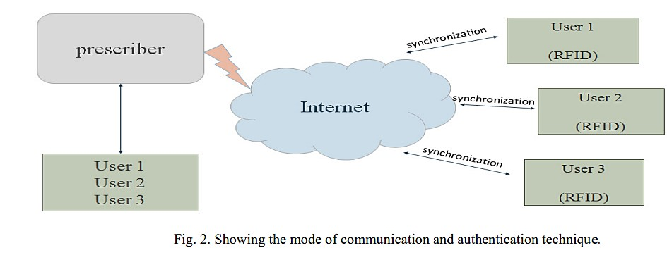

3. Useful Technique for Medicine Reminder and Monitoring System . After observing all the literature, the following technologies are identified which can prove

beneficial for designing of Medicine Reminder and Monitoring System for Secure Health Using IOT.

> UI: To make changes if any in system.

> Intelligent control: Control system comprising sensors for monitoring and reporting the state of the environment and its associated control software, which regularly check the medicine taken by patient or not . x IoT:( Internet of Things) has evolved from the convergence of wireless technologies, microelectromechanical systems (MEMS) and the Internet. The concept may also be referred to as the Internet of Everything. to exchange data of things or physical object, this is embedded with electronics, related software, sensors and network connectivity. Which allow to sensed and collect data remotely, it generate opportunity to direct integration between physical world and computer based system have economic, accuracy and efficiency benefits. x The use of open standard like ISO/IEEE 11073-20601 group of standards addressing the interoperability of personal health devices12

> MQTT messaging protocol will best suited due to less memory, processor and bandwidth13 x

The use of open source IOT cloud will be effective.

> RFID and RFID reader: RFID is utilized to give unique identification to user so that while remote monitoring the prescriber can distinguish the patient on same page14

> Web page: web page will be used for remote monitoring of medicine scheduled fallowed by patient and to upload the changes if any found after comparing the variation in medicine consuming activity in scheduling, quantity, timing of drug.

> Alarm System: The alarm system is used to give the indication of medicine through voice message.

>Appointment from home: The provision will be on the box which will take patient appointment of the doctor here, RFID will be the Identity of patient.

> Benefit of using RFID tag: Used for Encryption/Decryption Technology15 4.

Working flow chat

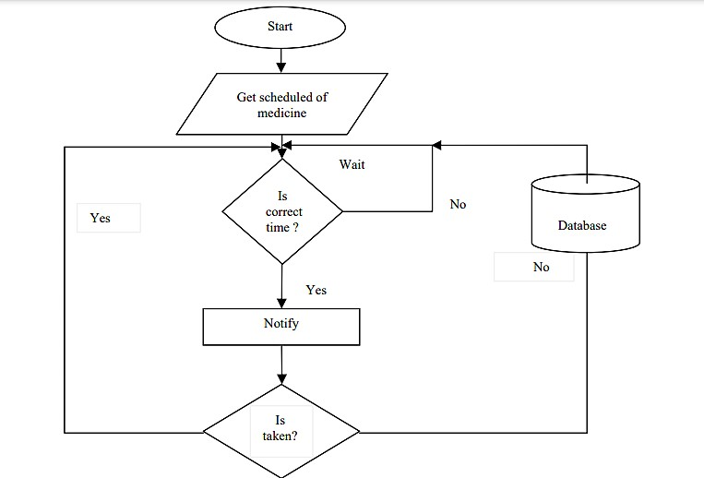

The conceptual working of medicine reminder and monitoring system in flow chart describes the scheduling and the procedure of taking medicine, if schedule is followed by patient or not the data will be stored in the cloud. The stored data will be used to analyze record of patient and further prescription will be give according to it.

1. Conclusion

For home health care various technology have evolved as review considered, in this paper medicine, its scheduling have well focused which is beneficial to improve efficiency of prescribed drug and reduce economic factor. To improve the existing home health care technique number of monitoring technology has observed which leads to home health monitoring system. The monitoring system can be implemented with sensing element and wireless module which should need to secure so that message containing the health related information should not be corrupt. IOT (Internet of Things) play a vital role in communicating the two devices, the use of messaging standard and communication protocol we can securely transfer the important messages regarding to health. open source IOT cloud will be effective for storing sensors data,the benefit of digitally storing is the retrieving of data is easy and faster manner in case of emergency for secure health. For the user personal identity

1. **Ideation Phase**

**3.1 Brainstorm & Idea Prioritization**

**Step-1: Brainstorm, Idea Listing and Grouping**

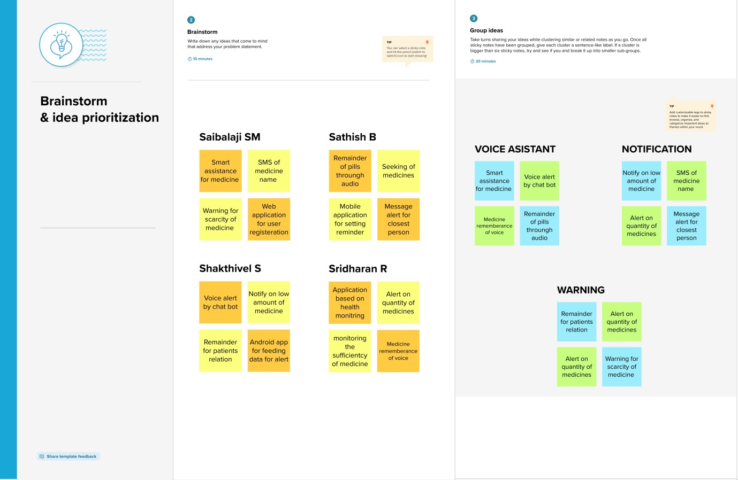

**Step-2: Idea Prioritization**

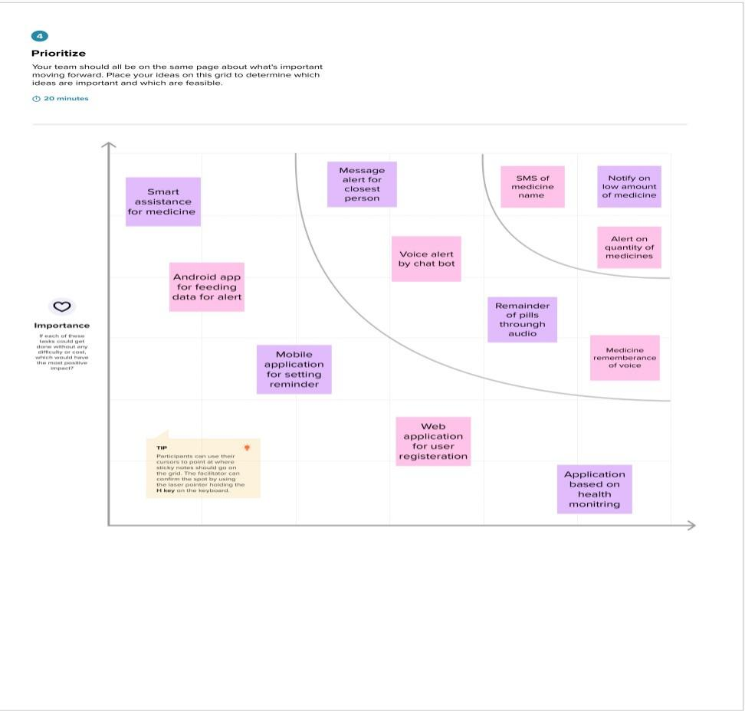

3.2 EMPATHY MAP:

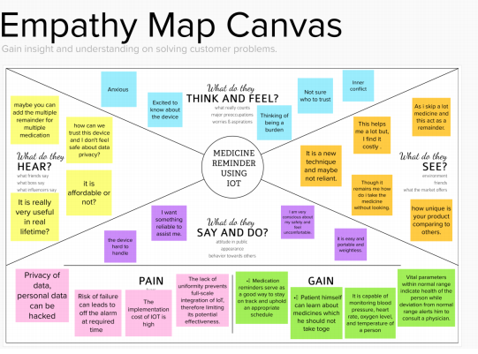

**4.PROBLEM STATEMENT**

**Personal assistant for senior who are self reliant**

**medicinal drug reminder app designed for individuals who regularly overlook to take their medications. An app is constructed for the caretaker which allows him to set the favored time and medicinal drug.You may hold music of your appointments Now, technology inclusive of affected person monitoring and clever domestic gadgets can automate obligations and techniques to guide seniors. Implementing gadgets, inclusive of, telemedicine and clever domestic gadgets, can carry peace of thoughts to households and cherished ones and more secure dwelling situations for seniors. Its parental characteristic distinguishes it from different apps at the market, permitting you to hold music of and remotely help your family who discover it tough to make use of such an app with their reminders. The tool will acquire the drugs call and regulate the consumer with voice command.**

**CUSTOMER PROBLEM STATEMENT:**

**>>** I am ambika

Age-50

I have low sugar and high blood pressure.

**>>** I am trying to:

remind to take injectable glucagon for low sugar And enalapril, lisinopril, perindopril and ramipril

for high bp

**>>**But :

lifestyle challenges, patient incompatibility, forgetting of medicine use, and nonexpert advice.

**>>**Because:

Due to patient Forgot, it will risk health of patient .

**>>**Which makes me feel:

Worry about patients health for careless of taking medicine due to forgotten .

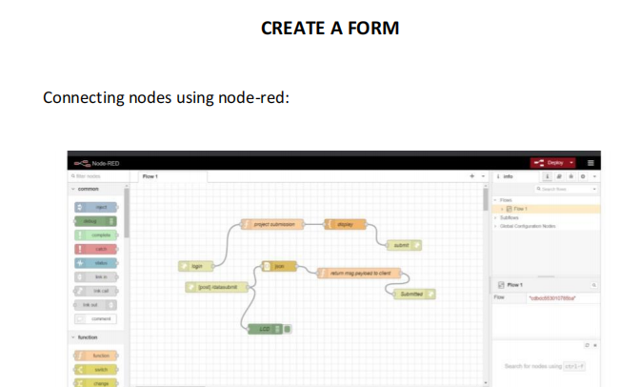

NODE RED

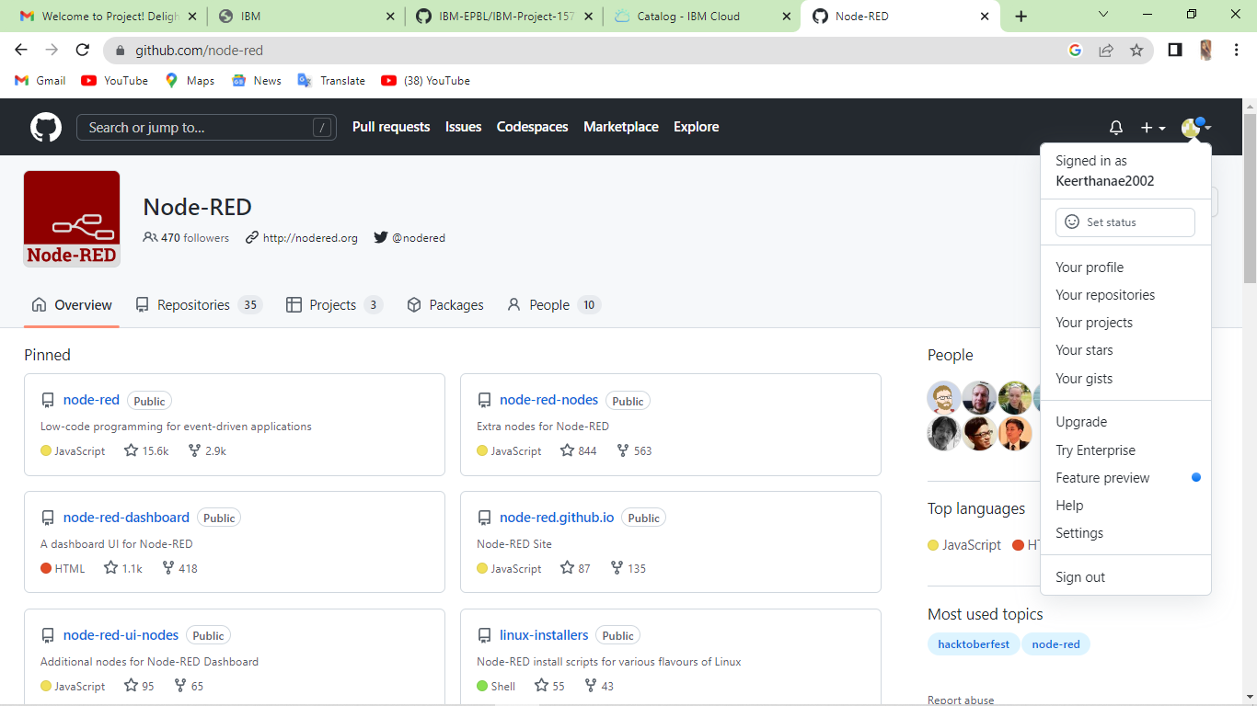

5.3TEXT TO SPEECH

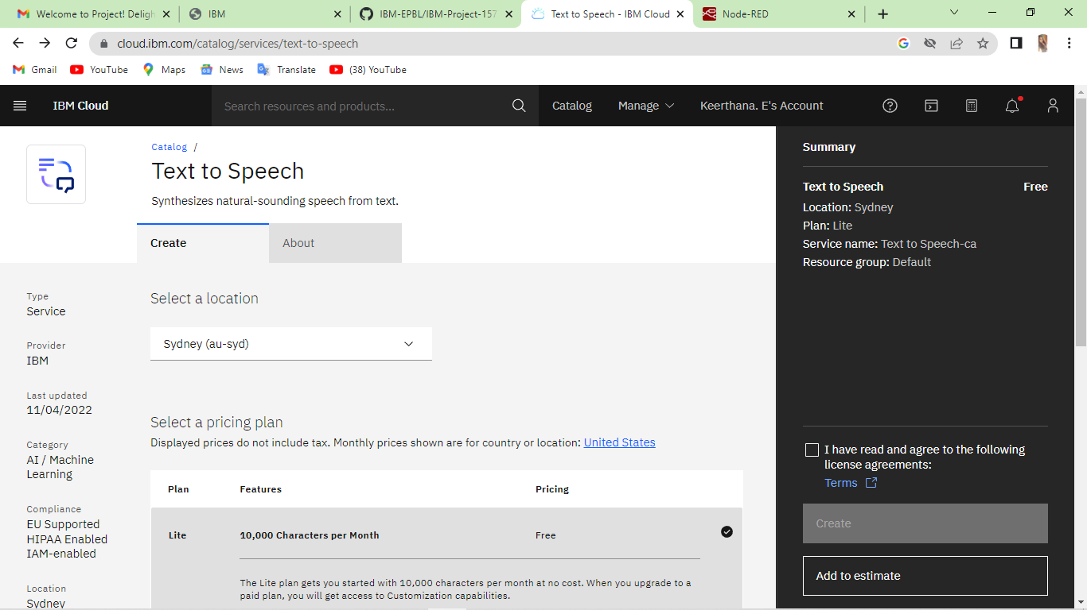

5.4WATSON 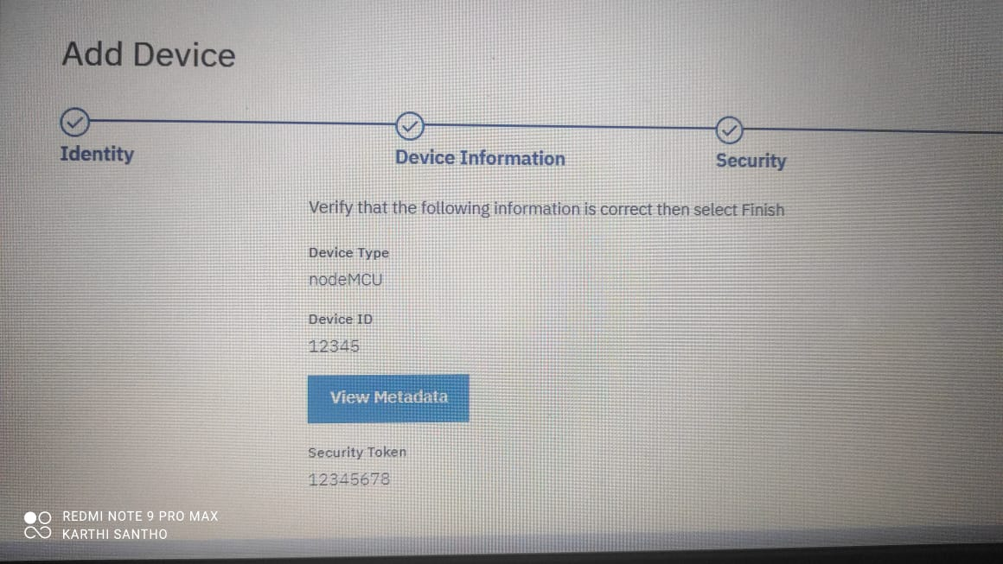

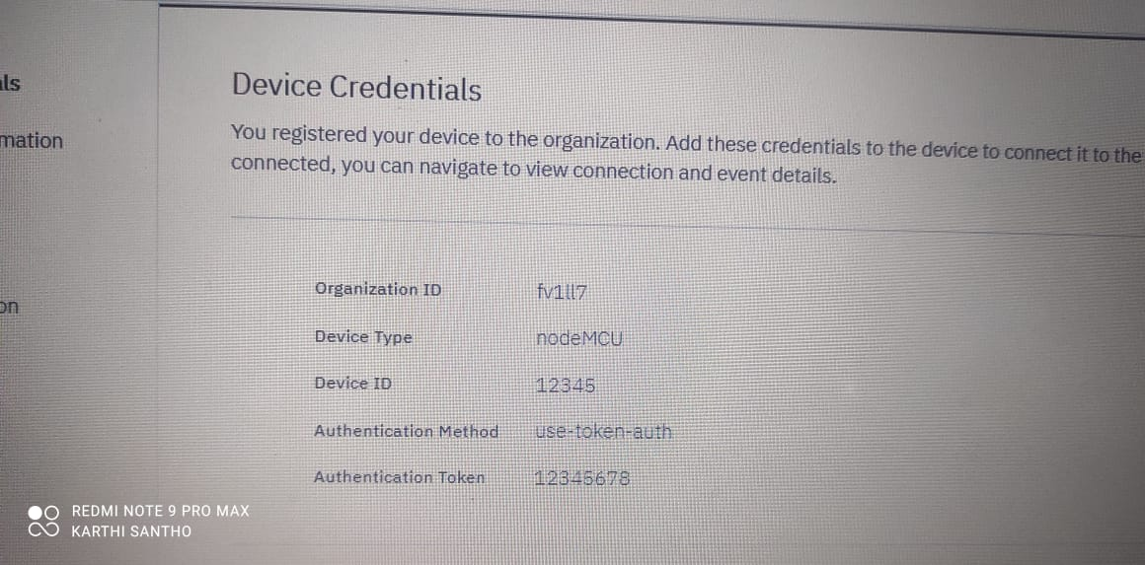

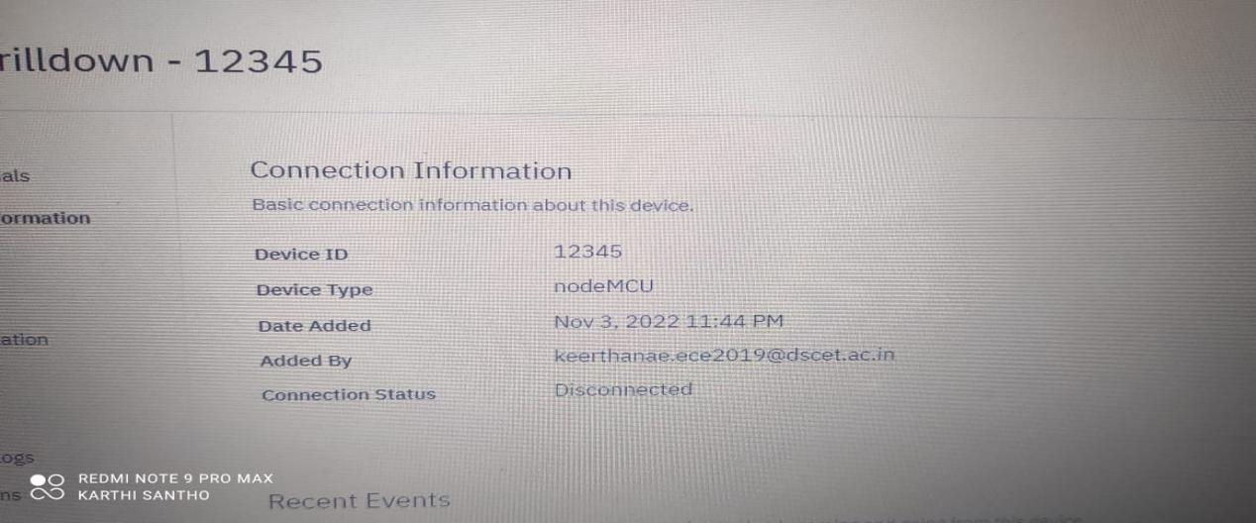

\\

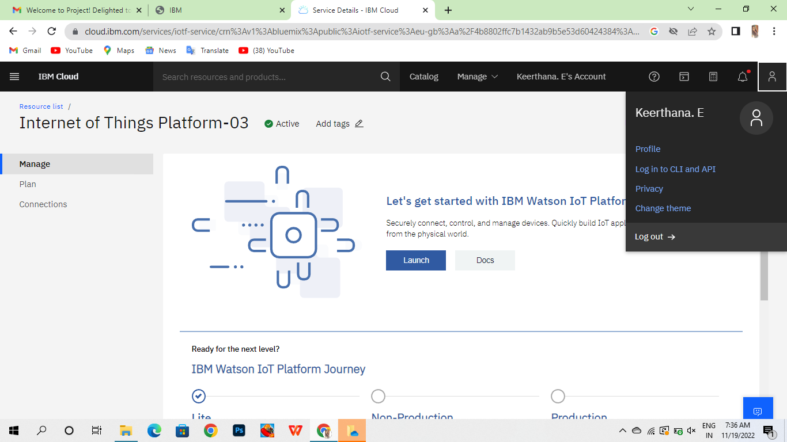

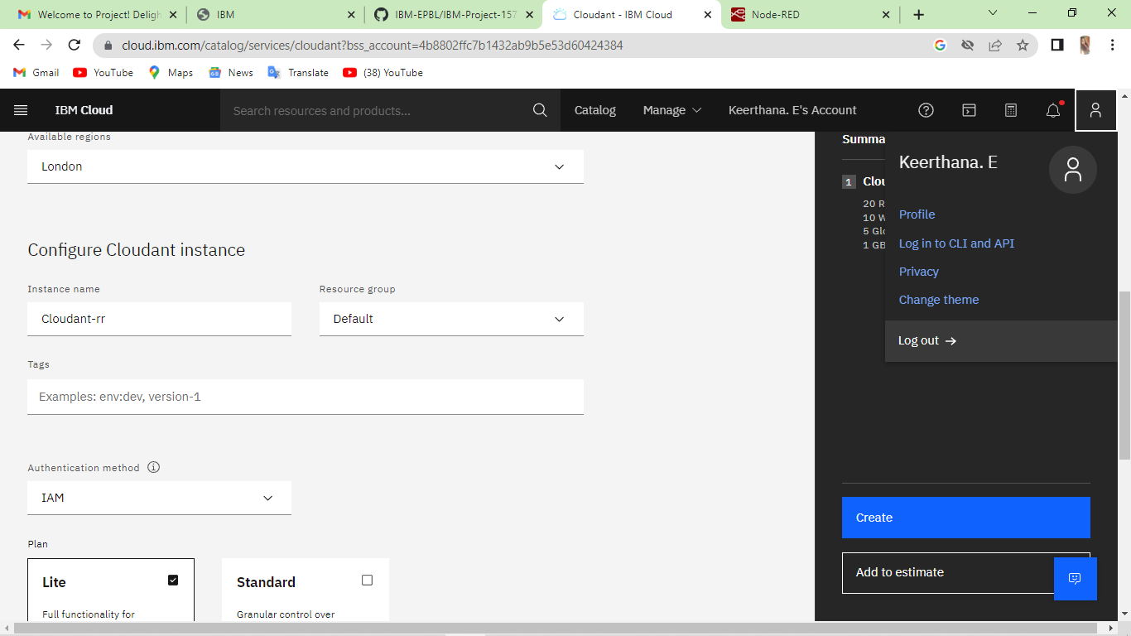

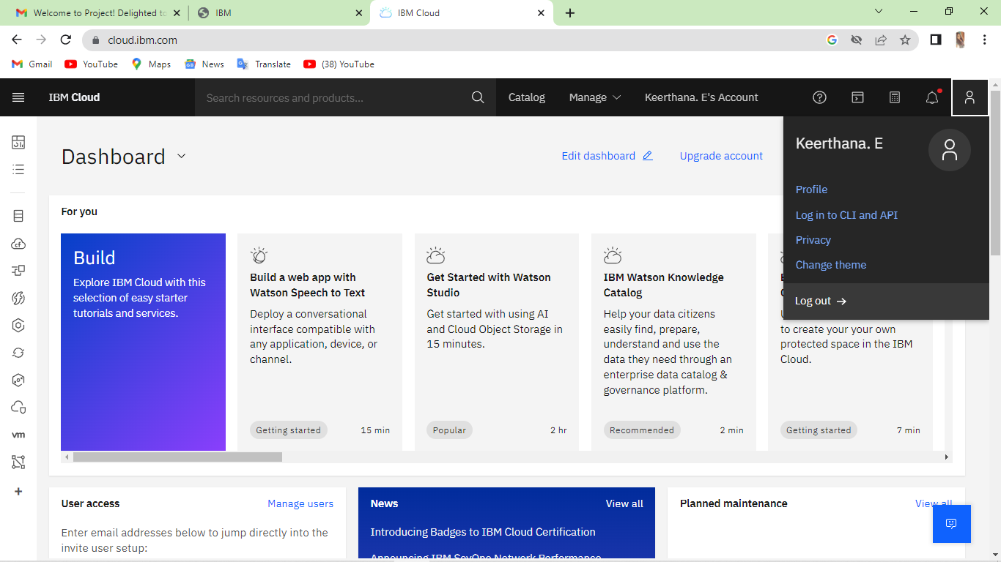

**6. Solution Fit**

**1.CUSTOMER SEGMENT(S) CS**

• Here the customers are the

elder people who needs to take

medicine regularly at correct time.

• Patients who can’t be monitored

24X7 by doctors.

• Visually challenged people who

are self-reliant.

**6. CUSTOMER CONSTRAINTS CC**

• Due to lack of internet.

• It should be present near to

them.

• Knowing the process of using

the applications.

• Registered user can use the

application.

**5. AVAILABLE SOLUTIONS AS**

• If customers forgot to take

medicine ,medcare application

helps them to take medicine at

right time.

• Alert the customer by notification

by SMS alarm.

• Make the registered users remind

their medicines through voice

commands of medicine names.

**2. JOBS-TO-BE-DONE /PROBLEMS**

**J&P**

• Rememberance of the medicine

to be consumed through voice.

• Message sent on regarding intake

of medicines to the closest

persons.

• Alert the patient about the low

amount of medicine.

**9. PROBLEM ROOT CAUSE RC**

• Doctors cannot monitor the

patients all the time.

• Visually impaired persons

needs an assistance.

• Elder people(self-reliant) who

needs care to be taken.

**7. BEHAVIOUR**

**BE**

• The customer can use ‘help’

option in the application to

getthe problem solved.

• The user can use user guide

available in the ‘about’ section

for reference.

**Define CS, fit into CC**

**Explore AS, differentiate**

**Focus on J&P, tap into BE, understand RC**

**Focus on J&P, tap into BE, understand RC3. TRIGGERS**

**TR**

• The customers are

introduced with this by the

doctors.

• By seeing ads on the internet.

**10. YOUR SOLUTION**

**SL**

Notifying of medicines names through

audio and message with the help of data fed

from the mobile application which is initiated

by web application which stores the user

details.

**8.CHANNELS of BEHAVIOUR CH**

**ONLINE:**

Customers can set reminder about their

medicines in online mode.

**OFFLINE:**

Customers get notification alert to

take medicine on proper time in offline

mode.

**4. EMOTIONS: BEFORE / AFTER EM**

**BEFORE**:

Customers forgot to take at right time which

affect their health.

**AFTER:**

Now after using medcare applications customers

are taking their medicines properly at correct

time.

**Identify strong TR & EM**

Extract onine & offline CHOF be

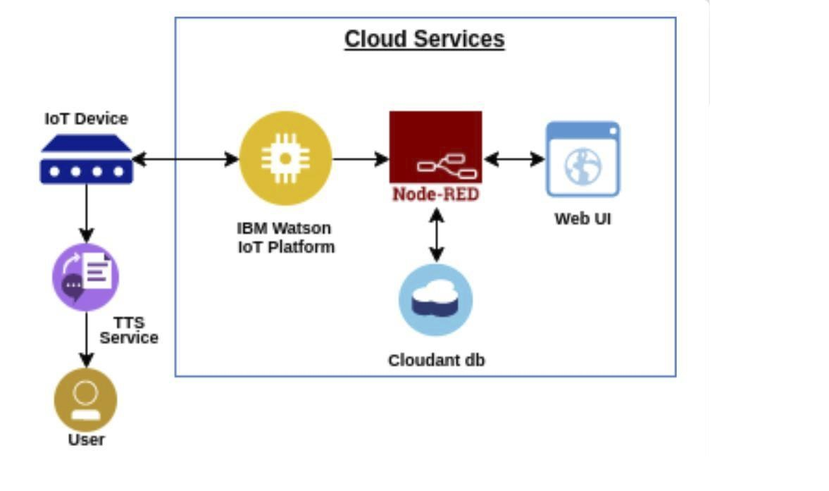

Project Design phase ‒ I

7. solution Template

|  |  |  |  |  |  |
| --- | --- | --- | --- | --- | --- |
| S.NO | PARAMETER |  |  |  | DESCRIPTION |
| 1 | PROBLEM STATEMENT(PROBLEM TO BE SOLVED) |  |  |  | 1 PROBLEM STATEMENT(PROBLEM TO BE SOLVED) Some human beings discover it hard to study new apps on this ever-increasing virtual environment, and those these days generally tend to overlook matters extra easily, consisting of taking their prescriptions. |
| 2 | IDEA / SOLUTION DESCRIPTION |  |  |  | Create a basic, easy-to-use app in order that customers don’t overlook their remedy schedules, can effortlessly find out pharmacies and clinics close to them. |
| 3 | NOVELTY / UNIQUENESS |  |  |  | It is a user-pleasant app that sends customers remedy and fill up reminders, gives drug interplay warnings, and facilitates caregivers control prescriptions for cherished ones. |
| 4 | SOCIAL IMPACT / CUSTOMER SATISFACTION |  |  |  | I built those proto-personas, or names, primarily based totally at the studies findings from the person interview. They might be vital to the relaxation of the layout process. All layout selections can be assessed and re evaluated the use of those personas, maintaining the person and their attitude in mind. |
| 5 | BUSINESS MODEL(REVENUE MODEL) |  |  |  | When it involves the enterprise there's no one-size-fits- all solution. The version you select relies upon for your goal audience , enterprise goals , and the sources you already posses. |
| 6 | SCALABILITY OF THE SOLUTION |  |  |  | As the version is included with cloud software , we will replace the consumer enjoy with out reinstalling a version and the character can preserve a the rest as much as the year. |
|  |  |  |  |  |  |

**8.Technical architecture**

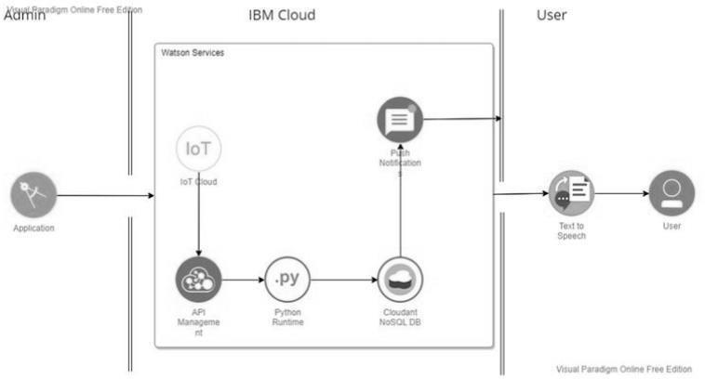

**Component**

**Description**

**Technology**

**1.**

User Interface

Mobile App

**HTML, CSS,**

**JavaScript**

**2.**

Application Logic-1

Mobile App to enter the Medicine

**Python**

Details weekly

**3.** Application Logic-2

Gets the medication data from

database

**IBM Watson IoT API**

**Call data**

**4.**

Application Logic-3

Converts the text to speech to

pronunciation for the user

**IBM Watson**

**Assistant**

**5.**

Database

Medication time and tablets nameon

daily and

**MySQL**

**6.**

Cloud Database

Call the data IBM Cloudant is usedand

user login credentials

**IBM DB2, IBM**

**Cloudant**

**7.**

File Storage

App code and IoT credentials are

stored and API keys

**IBM Block Storage**

**8.**

External API-1

To get the medicine box statusOpen or

not

**IBM box status API**

**9.**

External API-2

To get the login credentials in IBMDB2

**Username and**

**Password API**

**10.**

Machine Learning

Model

To convert the text into

speech for voice

command the tablet

details

**Text to speech**

**11.**

**Infrastructure**

**To host the server and**

**Cloud Foundry,**

**(Server / Cloud)**

**application**

**Node RedTable-2: Application Characteristics:**

**S.N**

**Characteristicso**

**Description**

**Technology**

**1.**

Open-Source

Frameworks

To develop the application interface,

we use

**MIT App Inventor**

**MIT APP**

**INVENTOR**

**2.**

Security

Implementations

To secure the users

logincredentials and

personal information

**SHA-256, OWASP**

**3.**

Scalable Architecture

To scale the application database

**IBM Auto scaling**

**4.**

Availability

To make use the

application and

dataare available

24/7

**IBM Cloud load**

**balancer**

**5.**

**Performance**

**To increase the performance the**

**application**

**In hosted in**

**thehigh**

**performanc**

**einstance**

**IBM instance**

9.Solution Requirements (Functional &

functional)

User Registration

Registration through Form Registration

through Gmail

2

User Confirmation

Confirmation via Email

Confirmation via OTP

3

Access Cloud services

Access the cloud service with correct credentials

Store the details in the database

4

IOT configuration

Fine Tuning the IOT device based onAccess

the Cloud DB via device Manage the request

and response effectively**Non-functional Requirements:**

**FR**

**No.**

**Non-Functional**

**Requirement**

**Description**

1

**Usability**

App can be used by anyone who has knowledge

about internet and

computer.

2

**Security**

For security, TFA is enabled and biometricsare

also added for user safety.

3

**Reliability**

Highly reliable since, It uses Trusted cloud

services like IBM

4

**Performance**

Performance is better compared to othermarket

products.

5

**Availability**

Available on mobile app.

6

**Scalability**

Using Cloud services, makes the scalability

higher the using traditionaldatabase.

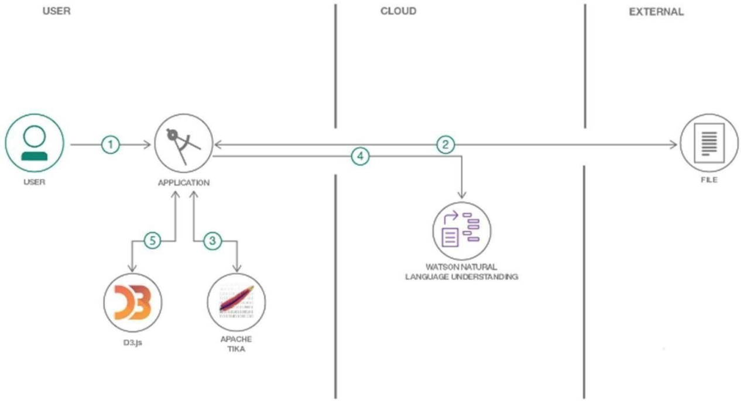

10.FUNCTIONAL REQUIREMENT

**User Type**

**Functional**

**Requireme**

**nt(Epic)**

**User**

**Story**

**Number**

**User Story / Task**

**Acceptance criteria**

**Priority**

**Release**

Customer

(Senior

citizen)

Caretaker

USN-1

As a user, I want to take Medicines

on time and monitor my health

I want to Take

Medicines On

time

High

Sprint-1

Customer

(Alzheime

r patient)

Smart

medicine

box

USN-2

As a user, I want to take my tablets on

time by voice command

I want to take my

tablets on time

by

voice

command

High

Sprint-1

Custome

r

(Mentally

idled

patient)

Caretaker

USN-3

As a user, my patient needs to take

medicines on time and monitoring the

activity

My patient needs

to take medicines

on time

Medium

Sprint-2

Custome

r (Coma

patient)

Caretaker

USN-4

As a user, my patient medication

time and prescription should load

in database for upcoming week

My patient medication

time and prescription

should be in database

list

Low

Sprint-4

Custome

r

(Disable

d

people’s)

Smart

medicine

box

USN-5

As a user, I need to take my medicine

in nearby places with light notification

I need to take my

medicine in nearby

places with

light

notification

Medium

Sprint 3

11.1 Sprint 1

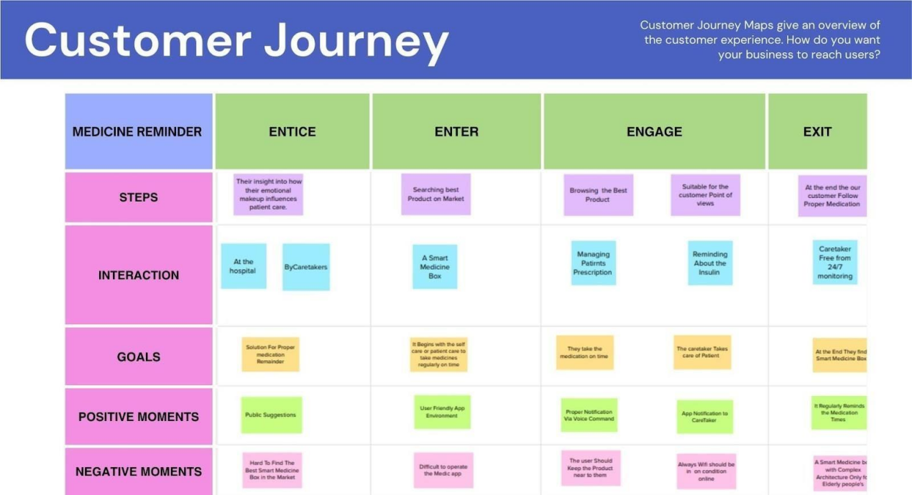

In this Sprint 1 we have found out what the elderly people used to and suffer in Alzheimer

disease .So the we had decided that we should find the solution of four different Ideasfrom our

teammates

1) Our teammate KEERTHANA E, Medicine Remainder for Alzheimer disease person to

keep an instant remainder for their medicine that is taken by them and keep them on

track of theirmedicine taken.

2) Our teammate JAYASRI P, A Medicine Remainder for elderly person that are

elderly person in home and Hospital and keep them check in Medicine that are

forgotten byCaretaker and Person around them.

3) Our teammate KOWSALYA N, A Stock Remainder of Medicine for Elderly Person and

keep the medicine in check every time if the medicine prolonged for another week and

have the refilled alarm for the medicine that need to taken.

4) Our teammate SOWMIYA S, A Scan of medicine to zoom and see the medicine those

are taken by the elderly person and keep in check of medication of elderly person. If

needed the medication can be upload the App.

By considering all the ideas that are given teammate .We conclude that are of decision made

by teammate is make a combine idea of Medicine Remainder App that feature of scanning of

medicine , medicine remainder at correct timing, Stock remainder.

What we should complete in sprint 1?The Issue collected from user

USN 1:As a user, I want to take Medicines on time and monitor my health

USN 2:As a user, I want to take my tablets on time by voice command

USN 3:As a user, I need to take my medicine and I am not able see the dosage of medicine

properlyUSN 4:As a user, Sometimes my medicine aren’t in stock and I usually forget the Stock of

my medication.

REQUIRED MATERIALS:

1 . RTC DS3231 module

2 . 16x2 LCD Display

3 . Buzzer

4 . Led(any color)

5 . Breadboard

6 . Push Buttons

7 . 10K Potentiometer

8 . 10K,1K Resistors

9 . Jumper Wires

10. ArduinoUno

Simulation:

Code:

//Medicine Reminder using Arduino Uno

// Reminds to take medicine at 8am, 2pm, 8pm/* The circuit:

LCD RS pin to digital pin 12

LCD Enable pin to digital pin 11

LCD D4 pin to digital pin 5

LCD D5 pin to digital pin 4

LCD D6 pin to digital pin 3

LCD D7 pin to digital pin 2

LCD R/W pin to ground

LCD VSS pin to ground

LCD VCC pin to 5V

10K resistor:

ends to +5V and ground

wiper to LCD VO pin (pin 3)*/

#include <LiquidCrystal.h>

#include <Wire.h>

#include <RTClib.h>

#include <EEPROM.h>

int pushVal = 0;

int val;

int val2;

int addr = 0;

RTC_DS3231 rtc;

const int rs = 12, en = 11, d4 = 5, d5 = 4, d6 = 3, d7 = 2;

// lcd

pins

LiquidCrystal lcd(rs, en, d4, d5, d6, d7);

#define getWellsoon 0

#define HELP_SCREEN 1

#define TIME_SCREEN 2//bool pushPressed;

//flag to keep track of push button

state

int pushpressed = 0;

const int ledPin = LED_BUILTIN;

// buzzer and led pin

int ledState = LOW;

int Signal = 0;

int buzz = 13;

int push1state, push2state, push3state, stopinState = 0;

//

int push1Flag, push2Flag, Push3Flag = false;

// push button flags

int push1pin = 9;

int push2pin = 8;

int push3pin = 7;

int stopPin = A0;

int screens = 0;

// screen to show

int maxScreen = 2;

// screen count

bool isScreenChanged = true;

long previousMillis = 0;

long interval = 500;

// buzzing interval

unsigned long currentMillis;

long previousMillisLCD = 0;

// for LCD screen update

long intervalLCD = 2000;

// Screen cycling interval

unsigned long currentMillisLCD;

//

Set Reminder Change Time

int buzz8amHH = 8;

//

HH - hours

##Set these for reminder time in

24hr Format

int buzz8amMM = 00;

//

MM - Minute

int buzz8amSS = 00;

//

SS - Secondsint buzz2pmHH = 14;

//

HH - hours

int buzz2pmMM = 00;

//

MM - Minute

int buzz2pmSS = 00;

//

SS - Seconds

int buzz8pmHH = 20;

//

HH - hours

int buzz8pmMM = 00;

//

MM - Minute

int buzz8pmSS = 00;

//

SS - Seconds

int nowHr, nowMin, nowSec;

// to show current mm,hh,ss

// All messeges

void gwsMessege(){

// print get well soon messege

lcd.clear();

lcd.setCursor(0, 0);

lcd.print("Stay Healthy :)");

// Give some cheers

lcd.setCursor(0, 1);

lcd.print("Get Well Soon :)");

// wish

}

void helpScreen() {

// function to display 1st screen in LCD

lcd.clear();

lcd.setCursor(0, 0);

lcd.print("Press Buttons");

lcd.setCursor(0, 1);

lcd.print("for Reminder...!");

}

void timeScreen() {

// function to display Date and time in LCD screen

DateTime now = rtc.now();

// take rtc time and print in display

lcd.clear();lcd.setCursor(0, 0);

lcd.print("Time:");

lcd.setCursor(6, 0);

lcd.print(nowHr = now.hour(), DEC);

lcd.print(":");

lcd.print(nowMin = now.minute(), DEC);

lcd.print(":");

lcd.print(nowSec = now.second(), DEC);

lcd.setCursor(0, 1);

lcd.print("Date: ");

lcd.print(now.day(), DEC);

lcd.print("/");

lcd.print(now.month(), DEC);

lcd.print("/");

lcd.print(now.year(), DEC);

}

void setup() {

Serial.begin(9600);

// start serial debugging

if (! rtc.begin()) {

// check if rtc is connected

Serial.println("Couldn't find RTC");

while (1);

}

if (rtc.lostPower()) {

Serial.println("RTC lost power, lets set the time!");

}

//

rtc.adjust(DateTime(F( DATE ), F( TIME )));

// uncomment this to

set the current time and then comment in next upload when u set the timertc.adjust(DateTime(2019, 1, 10, 7, 59, 30));

// manual time set

lcd.begin(16, 2);

lcd.clear();

lcd.setCursor(0, 0);

lcd.print("Welcome To");

// print a messege at

startup

lcd.setCursor(0, 1);

lcd.print("Circuit Digest");

delay(1000);

pinMode(push1pin, INPUT);

// define push button

pins type

pinMode(push2pin, INPUT);

pinMode(push3pin, INPUT);

pinMode(stopPin, INPUT);

pinMode(ledPin, OUTPUT);

delay(200);

Serial.println(EEPROM.read(addr));

val2 = EEPROM.read(addr);

// read previosuly saved value of

push button to start from where it was left previously

switch (val2) {

case 1:

Serial.println("Set for 1/day");

push1state = 1;

push2state = 0;

push3state = 0;

pushVal = 1;

break;

case 2:Serial.println("Set for 2/day");

push1state = 0;

push2state = 1;

push3state = 0;

pushVal = 2;

break;

case 3:

Serial.println("Set for 3/day");

push1state = 0;

push2state = 0;

push3state = 1;

pushVal = 3;

break;

}

}

void loop() {

push1();

//call to set once/day

push2();

//call to set twice/day

push3();

//call to set thrice/day

if (pushVal == 1) {

// if push button 1 pressed

then remind at 8am

at8am();

//function to start uzzing at

8am

}

else if (pushVal == 2) {

// if push button 2 pressed

then remind at 8am and 8pm

at8am();at8pm();

//function to start uzzing at

8mm

}

else if (pushVal == 3) {

// if push button 3 pressed

then remind at 8am and 8pm

at8am();

at2pm();

//function to start uzzing at

8mm

at8pm();

}

currentMillisLCD = millis();

// start millis for LCD screen

switching at defined interval of time

push1state = digitalRead(push1pin);

// start reading all push

button pins

push2state = digitalRead(push2pin);

push3state = digitalRead(push3pin);

stopinState = digitalRead(stopPin);

stopPins();

// call to stop buzzing

changeScreen();

// screen cycle function

}

// push buttons

void push1() {

// function to set reminder once/day

if (push1state == 1) {

push1state = 0;

push2state = 0;

push3state = 0;

//

pushPressed = true;EEPROM.write(addr, 1);

Serial.print("Push1 Written : "); Serial.println(EEPROM.read(addr)); // for

debugging

pushVal = 1;

//save the state of push

button-1

lcd.clear();

lcd.setCursor(0, 0);

lcd.print("Reminder set ");

lcd.setCursor(0, 1);

lcd.print("for Once/day !");

delay(1200);

lcd.clear();

}

}

void push2() {

//function to set reminder twice/day

if (push2state == 1) {

push2state = 0;

push1state = 0;

push3state = 0;

//

pushPressed = true;

EEPROM.write(addr, 2);

Serial.print("Push2 Written : "); Serial.println(EEPROM.read(addr));

pushVal = 2;

lcd.clear();

lcd.setCursor(0, 0);

lcd.print("Reminder set ");

lcd.setCursor(0, 1);

lcd.print("for Twice/day !");delay(1200);

lcd.clear();

}

}

void push3() {

//function to set reminder thrice/day

if (push3state == 1) {

push3state = 0;

push1state = 0;

push2state = 0;

//

pushPressed = true;

EEPROM.write(addr, 3);

Serial.print("Push3 Written : "); Serial.println(EEPROM.read(addr));

pushVal = 3;

lcd.clear();

lcd.setCursor(0, 0);

lcd.print("Reminder set ");

lcd.setCursor(0, 1);

lcd.print("for Thrice/day !");

delay(1200);

lcd.clear();

}

}

void stopPins() {

//function to stop buzzing when user pushes stop

push button

if (stopinState == 1) {

//

stopinState = 0;

//

pushPressed = true;pushpressed = 1;

lcd.clear();

lcd.setCursor(0, 0);

lcd.print("Take Medicine ");

lcd.setCursor(0, 1);

lcd.print("with Warm Water");

delay(1200);

lcd.clear();

}

}

void startBuzz() {

// function to start buzzing when time reaches

to defined interval

// if (pushPressed == false) {

if (pushpressed == 0) {

Serial.println("pushpressed is false in blink");

unsigned long currentMillis = millis();

if (currentMillis - previousMillis >= interval) {

previousMillis = currentMillis;

// save the last time you blinked the

LED

Serial.println("Start Buzzing");

if (ledState == LOW) {

// if the LED is off turn it on and

vice-versa:

ledState = HIGH;

} else {

ledState = LOW;

}

digitalWrite(ledPin, ledState);

}}

else if (pushpressed == 1) {

Serial.println("pushpressed is true");

ledState = LOW;

digitalWrite(ledPin, ledState);

}

}

void at8am() {

// function to start buzzing at 8am

DateTime now = rtc.now();

if (int(now.hour()) >= buzz8amHH) {

if (int(now.minute()) >= buzz8amMM) {

if (int(now.second()) > buzz8amSS) {

/////////////////////////////////////////////////////

startBuzz();

/////////////////////////////////////////////////////

}

}

}

}

void at2pm() {

// function to start buzzing at 2pm

DateTime now = rtc.now();

if (int(now.hour()) >= buzz2pmHH) {

if (int(now.minute()) >= buzz2pmMM) {

if (int(now.second()) > buzz2pmSS) {

///////////////////////////////////////////////////

startBuzz();//////////////////////////////////////////////////

}

}

}

}

void at8pm() {

// function to start buzzing at 8pm

DateTime now = rtc.now();

if (int(now.hour()) >= buzz8pmHH) {

if (int(now.minute()) >= buzz8pmMM) {

if (int(now.second()) > buzz8pmSS) {

/////////////////////////////////////////////////////

startBuzz();

/////////////////////////////////////////////////////

}

}

}

}

//Screen Cycling

void changeScreen() {

//function for Screen Cycling

// Start switching screen every defined intervalLCD

if (currentMillisLCD - previousMillisLCD > intervalLCD)

// save the

last time you changed the display

{

previousMillisLCD = currentMillisLCD;

screens++;

if (screens > maxScreen) {screens = 0; // all screens over -> start from 1st

}

isScreenChanged = true;

}

// Start displaying current screen

if (isScreenChanged)

// only update the screen if the screen is changed.

{

isScreenChanged = false; // reset for next iteration

switch (screens)

{

case getWellsoon:

gwsMessege();

// get well soon message

break;

case HELP_SCREEN:

helpScreen();

// instruction screen

break;

case TIME_SCREEN:

timeScreen();

// to print date and time

break;

default:

//NOT SET.

break;

}

}

**11.2 Sprint 2**

**software (Create device in the Iot watson platform, workflow for Iot scenarios using local**

**NODE-RED)**

**Time Taken : 6 days**

As we have completed our simulation test and briefing every objectives of the project . So we have

REQUIRED SOFTWARE:

MIT App, IBM Watson IoT Platform, IBM Cloud, IBM Node-RED, Jira Software

The question that are raised during our session How, When, why are doing the project .And had

the session by Service was the main motive to be produced.

And what we did **on this** SPRINT 1 is that we **determined** the **aspect which might be wanted** for the

**mission** and **carried out** a dry **check** and had a **stay dialogue consultation of ways** the **mission have**

**to** be designed **and the way it's far** used **successfully via way of means of the usage of** required

software.

How was required Software useful and how our team did it?

We used the **MIT App** to built to use the App that can be reached to End User.

**IBM Node – RED** used to connect all the process that are made by the MIT App and process the

data .

**IBM Watson IoT Platform** is used to output to user but it is useful that it run on IBM Cloud.

**Jira Software** it is used for remainder for work is seen in the software and essentially gives the

burn down chart which can seen that our work done of every week is reflected in the Jira Software.

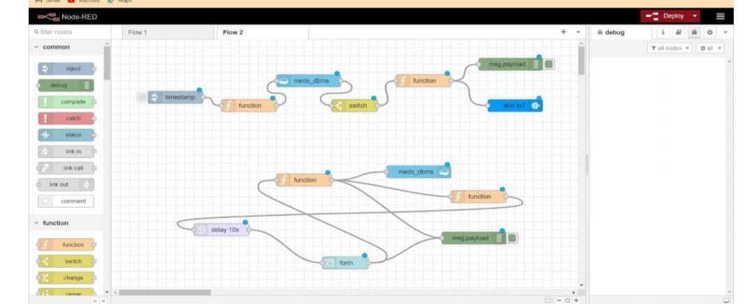

**11.3 SPRINT 3:**

MIT App inventor, dashboard (application for your project using MIT App, design the

model and test the app) Simulation :

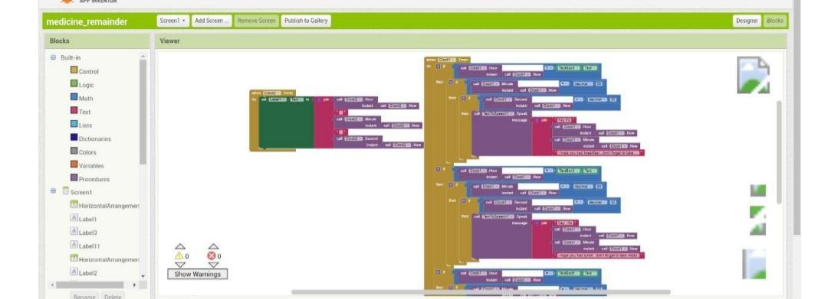

**11.4 SPRINT 4**

**web UI (to make the user interact with the software)**

**Time taken : 6 days**

The Medicine remainder App the below Web UI shows that the remainder is given morning,

evening and night .If needed the App can Edit the time of medicine taken.

**Feature :**

• Medicine remainder on time

• If any dose missed, alert will be provided for the emergency number in contact

• Provides information about the medicine intake such as the medicine name, dose and

dosage route.

• It also reminds the reminds stock of medicine to be purchased a week priory

• The update of the patient Body Temperature and humidity measure before medication is

taken.

• The remainder is as following steps The Message given as “TAKE THE MEDICINE” and

following that the patient has not taken medication after 5 minutes of gap the another

remainder is given “FORGOT TO TAKE MEDICIENE ” and if the medication is taken

the message is given as “TAKEN MEDS”

• **Project planning phase**

**12.2 Milestone and Activity list**

Team Leader

**Keerthana. E**

Team ID

**PNT2022TMID26833**

Project Name

**Personal assistance for seniors who are**

**selfreliant**

**TITLE**

**DESCRIPTION**

**Literature**

**Survey &**

**Information**

**Gathering**

Gathering information by

refering technical papers

research publications which

describes literature survey.

**Prepare**

**Empathy Map**

To establish users pain and

gain prepare the empathy

map canvas on problem

statement.

**Ideation**

Establishing brainstorm

sessions and emphasize the

top ideas based on the

importance of scalability

and feasibility.

**Proposed**

**Solution**

Prepare the proposed

solution which describes

idea,uniqueness,customer

satisfaction,business model

and scalability of solution.

**Problem**

**Solution Fit**

Prepare problem solution

fit which describes the

existence of problem.

**Solution**

**Architecture**

Defining process of

developing solution based

on predefined processes. **Customer**

**Journey**

Prepare a customer journey

map which understand the

customers

on users interaction and

experiences from scratch to

finding solution.

**Functional**

**Requirement**

Prepare the functional

requirement document

which specifies the

requirements.

**Data Flow**

**Diagrams**

Draw the data flow

diagrams based on problem

statement.

**Technology**

**Architecture**

Prepare a technology

architecture diagram which

describes the working.

**Prepare**

**Milestone &**

**Activity List**

Prepare the milestone and

activity list of the project.

**Project**

**Development -**

**Delivery of**

**Sprint-1, 2, 3 &**

**4**

Develop and submit the

developed code by

implementing and testing

it.

**12 .Project Planning Phase**

**12.1 Sprint delivery plan**

**Product Backlog, Sprint Schedule, and Estimation**

Use the below template to create product backlog and sprint schedule

**Sprint**

**Functional**

**Requirement (Epic)**

**User Story**

**Number**

**User Story / Task**

**Story Points**

**Priority**

**Team Members**

Sprint-1

IBM Watson IOT

platform

USN-1

Creating devices and board and generating data

10

medium

Keerthana. E

Kowsalya. NSprint-2

Storing Data using

node-red

USN-2

Storing the data in IBM Cloudant DB through

node-red functions

20

High

Keerthana. E

Jayasri. P

Sprint-3

IoT device/

Microcontroller

Board

USN-4

The board connect with the cloud and retrieve the

information and remain the peoples

20

Low

Sowmiya. S

Kowsalya. N

Sprint-4

Reminder (TTS)

USN-5

Getting the speech reminder to users to take their

tablet

10

High

Keerthana. E

Jayasri. P

Kowsalya. N

**Sprint**

**Functional**

**Requirement (Epic)**

**User Story**

**Number**

**User Story / Task**

**Story Points**

**Priority**

**Team Members**

Sprint-1

IBM Watson IOT

platform

USN-1

Creating devices and board and generating data

10

medium

Keerthana. E

Jayasri. P

Kowsalya. N

Sprint-4

Reminder (TTS)

USN-5

Getting the speech reminder to users to take their

tablet

10

High

Keerthana. E

Sowmiya. S

Jayasri.

**Project Tracker, Velocity & Burndown Chart: (4 Marks)**

**Sprint**

**Total Story**

**Points**

**Duration**

**Sprint Start Date**

**Sprint End Date**

**(Planned)**

**Story Points**

**Completed (as on**

**Planned End Date)**

**Sprint Release Date**

**(Actual)** Sprint-1

20

6 Days

30 Oct 2022

05 Nov 2022

20

4 nov 2022

Sprint-2

20

6 Days

31 Oct 2022

05 Nov 2022

20

6 nov 2022

Sprint-3

20

6 Days

07 Nov 2022

12 Nov 2022

20

13 nov 2002

Sprint-4

20

6 Days

14 Nov 2022

19 Nov 2022

20

14 Nov 2022

**Velocity:**

Imagine we have a 10-day sprint duration, and the velocity of the team is 20 (points per sprint). Let us calculate the team’s average velocity (AV) per iteration unit

(story points per day)